EES Investigation 2
How is the Metric System used?
Introduction Points: |180
Have you ever assembled furniture before? Let’s imagine that you’re assembling a TV stand. You gather everything you think that you’ll need: the directions, a big screwdriver, a ½” socket and ratchet, some thread locker and a flashlight. However, when you go to tighten the first bolt, you find out that your half inch wrench is just a little bit too small. What size would it be? 9/16”? 5/8”? Maybe 17/32”? Unless you are very familiar with standard wrench sizes, it will be a guess-and-check game to find the right size. Now- let’s say that you’re assembling a TV stand from IKEA that is equipped with metric sized bolts. If your 12mm wrench is just a little too small, it’s pretty easy to figure out that you’ll need a 13mm wrench to get the job done.
Objectives
1. To investigate various uses of the Metric System.
2. To become more familiar with utilization of the Metric System
3. To introduce appropriate laboratory procedure.
Materials
Rulers Graduated Cylinders Beakers
Balances Water Various objects to measure
Procedure
1. In your groups, determine the measurements of the following items (A, B, C):
--------------------------------------------------------- A
---------------------------------------- B
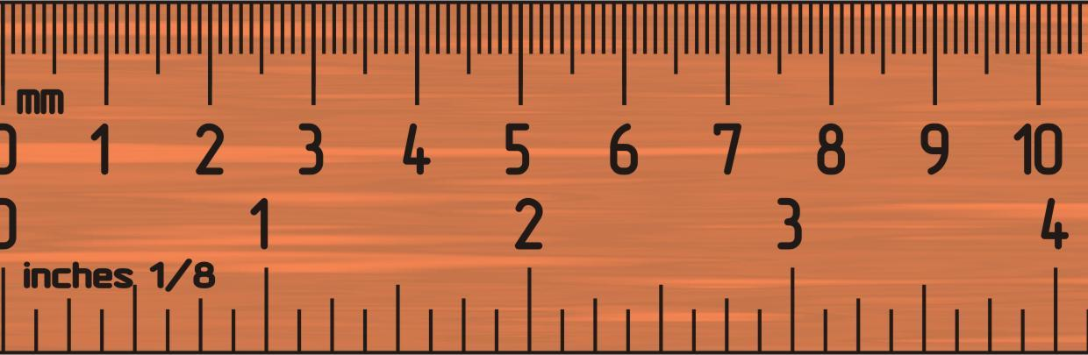
------------------------------------------------------------------------ C
What was the measurement of A? (5 points)

What was the measurement of B? (5 points)

What was the measurement of C? (5 points)

How was measurement A different from measurement C? Which units did you use to measure C? (10 points)

2. Obtain two of the wood blocks. Make sure to report which block you were measuring. What is the length of each of your blocks? (5 points)

What is the volume of some of your blocks? (5 points)

How did you measure volume? (5 points)

What is the mass of a block? (5 points)

3. Obtain some of the irregularly shaped materials. How will you find the volume of these materials? Explain the process. (5 points)

What is the volume of some of these materials? Make sure to report which item you determined the volume of.
(5 points)

4. Observe the two thermometers. What is the temperature of thermometer A in Celsius? What is temperature of thermometer B in Farenheght? (5 points)
A: B:
How did you do the conversion (explain the steps)? (10 points)

5. Observe the two beakers of liquid. What is the mass of the green liquid in the beaker? What is the volume of the green liquid in the beaker? How thick is the green liquid? (15 points)

What is the mass of the blue liquid? What is the volume of the blue liquid? How thick is the blue liquid? (15 points)

6. Observe the two balloons. What is the mass of the gas in balloon A? What is the volume of the gas in balloon A? (10 points)

What is the mass of gas in balloon B? What is the volume of gas in balloon B? (10 points)

How did the mass and volume of the gasses compare to the mass and volume of the liquids? (10 points)

Study Questions
1. Why would scientists use the metric system over the standard system? (5 points)

2. What does the prefix of the unit (in the metric system) have to do with the overall size of the measurement? (5 points)

3. We measured regular shaped objects and irregular shaped objects. Provide three examples of when you would need to measure a irregularly shaped object. (15 points)
a.
b.
c.
4. Let’s say that you decide to perform one of our labs at home, to make sure that you understood it in class. You need to measure the diameter of a petri dish, and report the results in centimeters. However, you only own a standard (inch) ruler. Knowing that 25.4mm makes up one inch, what would be the diameter you’d report of a 3 ¼” petri dish? (5 points)

5. Does the volume of an object ever compare to its mass? What do we call this type of measurement, provide three examples of materials that vary in the measurement, and rank them from highest to lowest. (5 points)

6. You’re driving to Mexico for Spring Break. You see that the speed limit is 90 Kilometers Per Hour, but your American-made car only has a speedometer that reads in Miles Per Hour. How fast is 90KPH, in MPH? After traveling at the maximum speed limit for an hour and a half, how far have you gone? (10 points)

7. Suppose you take a balloon, blow it up, then stick it in either the refrigerator or the freezer. What would happen to the balloon? Why does this happen? Explain. (5points)

Formulas
V=a³
V=πr²h
V=lwh
V=(4/3)πr³
V=(1/3)Bh
V=(1/3)πr²h
1in=2.54cm
1m=39.37in
1pc=1.91693x10¹³mi
[°C] = ([°F] − 32) × ⁵⁄₉

