Ethnobotany Re-cap Points: |330

Honey Mesquite. Realistically color in the following diagram: (30pt)
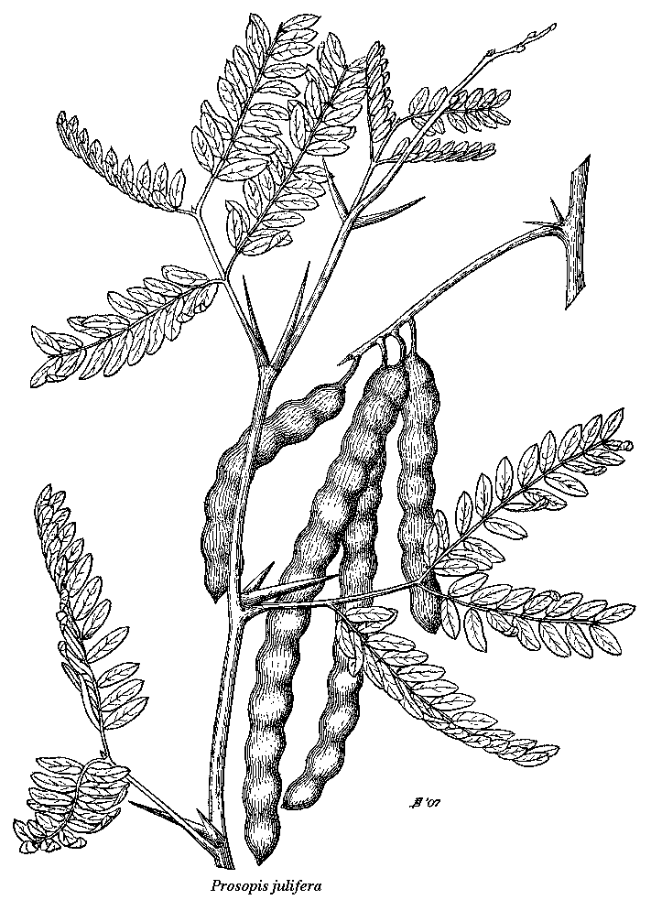
1. Which deserts does the Honey Mesquite inhabit? (10pt)

2. How would Native Americans use the Honey Mesquite for food? (10pt)

3. How would Native Americans use the Honey Mesquite for medicine? (10pt)

4. How would Native Americans use the Honey Mesquite for fuel? (10pt)

5. Which groups of Native Americans used the Honey Mesquite? (10pt)

6. Indicate (with color) the range of the Honey Mesquite below: (30pt)

Saguaro Cactus. Realistically color in the following diagram: (30pt)

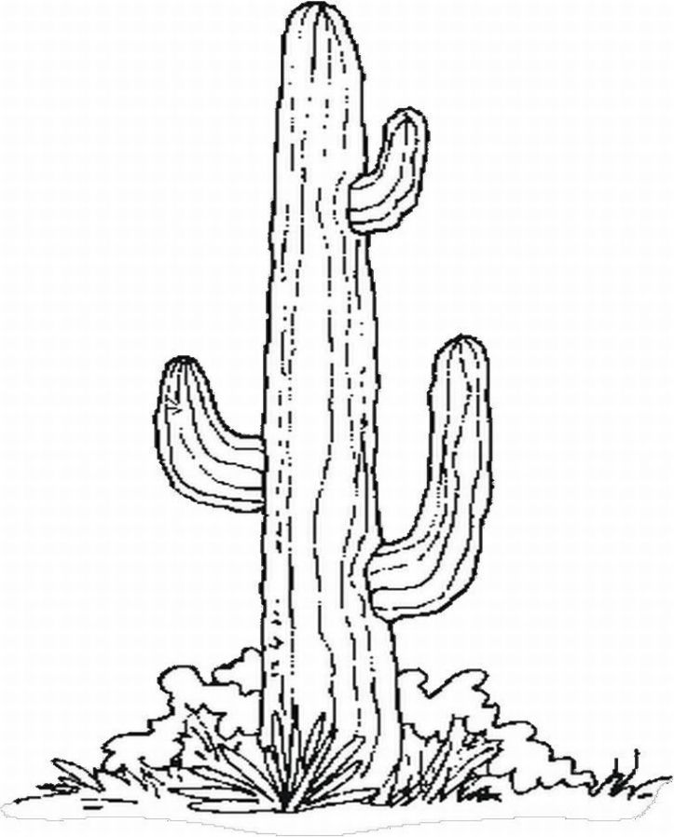
1. Which deserts does the Sagharo inhabit? (10pt)

2. How would Native Americans use the Saguaro for food? (10pt)

3. What is the sole nocturnal pollinator of the Saguaro? (10pt)

4. Describe the process where a Saguaro can heal itself from damage, like from a Gila Woodpecker. (10pt)

5. Which groups of Native Americans regard the Saguaro as very important or sacred? (10pt)

5. Indicate (with color) the range of the Saguaro below: (30pt)

Joshua Tree and Soaptree Yucca. Realistically color in the following diagrams: (30pt)

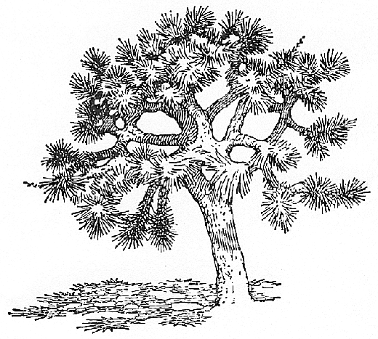
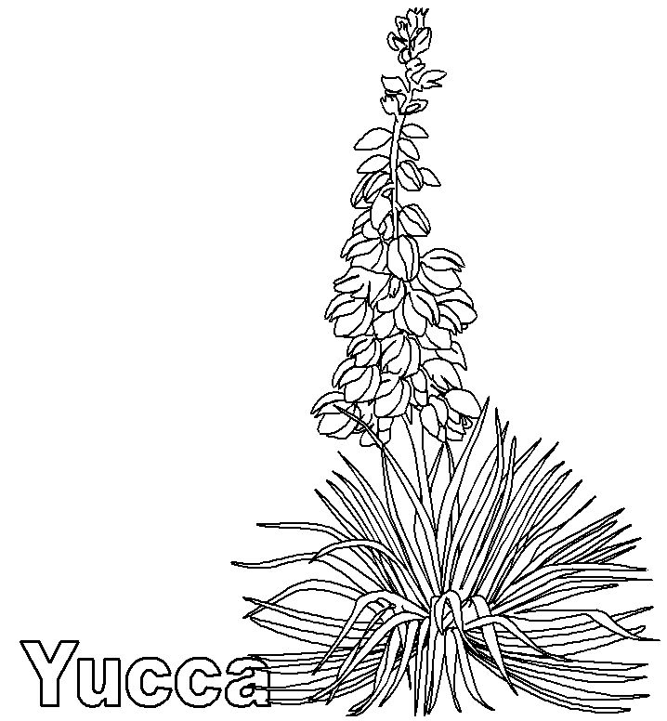
1. Which deserts do the Joshua Tree and the Soaptree Yucca inhabit? (10pt)

2. How would Native Americans use the JT/STY for food? (10pt)

3. What are some other Native American uses of the JT/STY?? (10pt)

4. Explain why (although there are plenty of them) the Joshua Tree and Saguaro are protected. (10pt)

5. Which groups of Native Americans used the JT/STY? (10pt)

6. Indicate (with color) the range of the Joshua Tree and ST Yucca below. Use different colors: (30pt)

